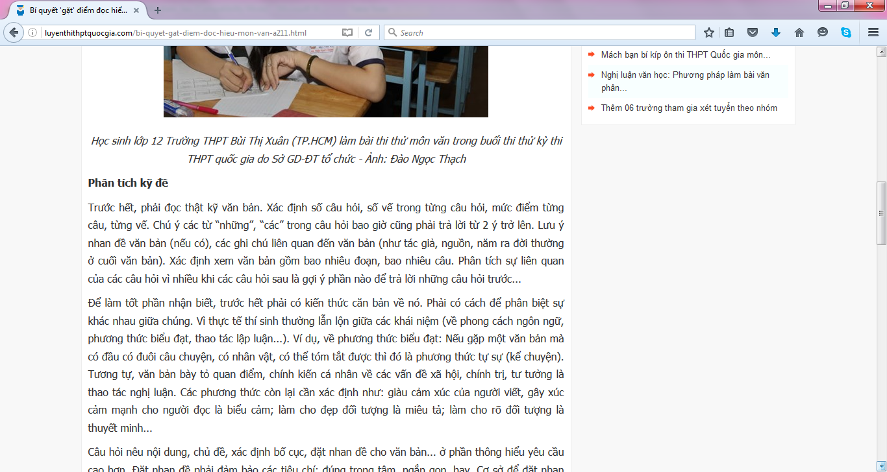http://luyenthithptquocgia.com/bi-quyet-gat-diem-doc-hieu-mon-van-a211.html
361


